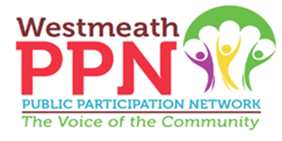
Environment, Climate Action, Rural Water & Emergency Services
Strategic Policy Committee (SPC)
Overview

Who to Contact: | Email: ppn@westmeathcoco.ie  Phone: 044 9338903
Who are We: | A committee of representatives from the following sectors:  Elected members from Westmeath County Council (5)  Agriculture/Farming (1)  Public Participation Network Representative (3)
What We Do: | The Environment, Climate Action, Rural Water and Emergency Services SPC advises Westmeath County Council on: Environmental protection measures such as waste management, river basin management, litter control, tree management, energy efficiency and climate action.
How Often We Meet: | Approximately 4 times per year  Athlone & Mullingar
Role of PPN Representative: | The following is what is expected of the PPN Representative in their role:  - To gather and present the views of member groups in the PPN.  - To bring issues of relevance from the community to the SPC.  - To give feedback to the community by attending thematic/linkage committee meetings.  - To return a report to the Secretariat following their attendance at Committee meetings.

