Road Safety Working Together Group
Who to Contact: | Name: Colm Smith  Email: colm.smith@westmeathcoco.ie  Phone: 0449332288
Who are We: | The Government Road Safety Strategy 2021-2030 is Ireland’s fifth Road Safety Strategy. The primary objective of the Strategy is to reduce the number of deaths and serious injuries on Irish roads by 50% by 2030. It adopts the “Safe System” approach and each Action Plan underpinning the Strategy sets out actions within seven priority intervention areas.  The Phase 2 Action Plan, which will run until the end of 2027, centres on a set of 12 Primary Actions to be delivered in collaborative partnership by actors across the sector and which aim to deliver significant or transformative impacts for road safety in Ireland. The senior stakeholders involved will be responsible for driving delivery of these primary actions. The Action Plan also includes 77 complementary Supporting Actions that partners will deliver in the coming years in support of Ireland’s road safety objectives.
What We Do: | Each Local Authority RSWTG is required to agree and publish a multi-agency Road Safety Action Plan detailing the action deliverable within the local authority administrative area by the relevant agencies and to publish an annual review on progress with implementation.
WPPN Pillar | Any
WPPN District | Either Mullingar or Athlone
How We Meet: | Approx. 4 times per year - Meeting venues in Athlone & Mullingar - office hours
Term of Office | Lifetime of the current council.
Role of PPN Representative: | The PPN Representative, using the skills and abilities they have developed through working with their own group, is expected to gather and present the views and opinions of all member organisations (including, but not limited to, his/her own group) of the PPN body which nominated him/her.  The Representative brings issues of relevance from the community to the Road Safety Forum and gives feedback to the community by filling in the Representative Report after every meeting they attend on the PPNs behalf.

Please return completed Nomination form for one PPN Rep position to the Road Safety Forum from any Pillar

- Community & Voluntary
- Social Inclusion
- Environment

For more details in relation to any of above please contact Westmeath PPN - Public Participation Network, Community Development Section, Westmeath County Council, Áras an Chontae, Mullingar, Co. Westmeath, N91 FH4N
Direct Line: 044 9332157 Email: ppn@westmeathcoco.ie

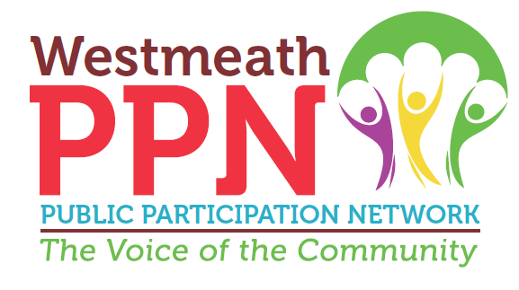
Westmeath Public Participation Network (WPPN) Nomination form for

Road Safety Forum
Note any person who wants to be considered as a PPN Representative; must

1. Complete in full the appropriate nomination form
2. Nominees should ensure that they understand the time commitment, required attendance etc relating to the position applied for (See over)
3. Be proposed and seconded by 2 members of their own WPPN registered group
4. Include a short Biography (max 200 words) of the nominee for inclusion on WPPN Ballot Sheet
5. Nomination Groups are asked to prove they are an active organisation through the provision of a Copy of the Minutes of their last AGM or other relevant documents.
6.. Ensure nomination form is returned to Westmeath PPN by closing date for applications Monday March 30th, 2026, at 4pm via email: ppn@westmeathcoco.ie

Nominating Group: ______________________________ Group PPN number: ______

Nominee Name: ______________________________________________________

Nominee address: ______________________________________________________

Nominee Phone Number: _____________ Email: _____________________________

Proposed by: __________________________ Position in Group: _________________

Signed by Proposer: ______________________________________________________

Seconded by: __________________________ Position in Group: _________________

Signed by Seconder: _____________________________________________________

Signed by nominee: ________________________________ Date: ________________
This form collects your name, email & phone number only for the purpose of WPPN elections
and related communications; it will not be used for any other purpose.

Biography of Nominee (200 words)

Notes:
- All PPN reps are obliged to sign the Reps charter
- In the event of more nominations than vacancies available, an election will be held.
- A panel will be created following election process to fill any current or future vacant positions.
- WPPN Reps are expected to gather and present the views and opinions of member organisations (including, but not limited to, his/her own group) of the WPPN body which elected him/her
- WPPN Reps are required to sign Reps Charter and adhere to WPPN reporting mechanisms, constitution and policies.
- WPPN representative expenses will be paid in accordance with Financial Policy of WPPN
- WPPN is non-political, non-sectarian and adheres to CVSP 8/2018 re PPNs and Engagement in the Political Process
- This form collects your name, email & phone number only for the purpose of WPPN elections and related communications; it will not be used for any other purpose.
- For more info contact Mark Ahern at ppn@westmeathcoco.ie or 044 9332157

